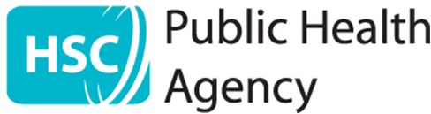

Press Release
Consultation begins on volunteering in health and social care
10 January 2014
The Health and Social Care Board and Public Health Agency have developed a draft plan for volunteering in health and social care.
Volunteering has always played a significant role in the delivery of health and social care in Northern Ireland. Volunteers add value to the work of paid staff by providing befriending, meeting and greeting, transport, chaplaincy, meal time support, breastfeeding support and many other roles.
The Health and Social Care Board commissioned Volunteer Now to support the development of a three-year regional plan for volunteering in partnership with the Public Health Agency and Health and Social Care Trusts across Northern Ireland.
This plan sets out a series of proposals to:
- Promote and support the role of volunteers within health and social care
- Ensure that the commissioning of services from organisations using volunteers is informed by good practice guidelines and standards
- Encourage health and social care organisations to enable employees to contribute to employer supported volunteering.
Fionnuala McAndrew, Director of Social Care and Children, Health and Social Care Board, said:
“Volunteers make an important contribution in health and social care across Northern Ireland. Now we want to hear what the public think about the draft plan for volunteering in health and social care and I would encourage all those interested to respond.”
The consultation documentation, as well as details of how to respond are available online at www.hscboard.hscni.net/consult or www.publichealth.hscni.net/consultations
For printed copies of the consultation documentation or alternative formats please telephone 028 9031 1611 extension 425 or email Lesley.blackstock@hscni.net
The closing date for responses is 5pm on Friday 18 April 2014.
ENDS
For media enquiries please contact HSCB Communications on 028 9055 3740 or PHA Corporate and Public Affairs on 028 9055 3663.

